Name : Rochak Chhetri
Student ID : 12323983

e-portfolio – 2 Ethics in ICT and Society
A collection of artefacts that demonstrate what I have learnt about ethics in ICT and society this week
Artefact: Artificial intelligence raises profound moral questions for all of humanity to answer
Why the ethics of AI cannot be left to the companies that build it
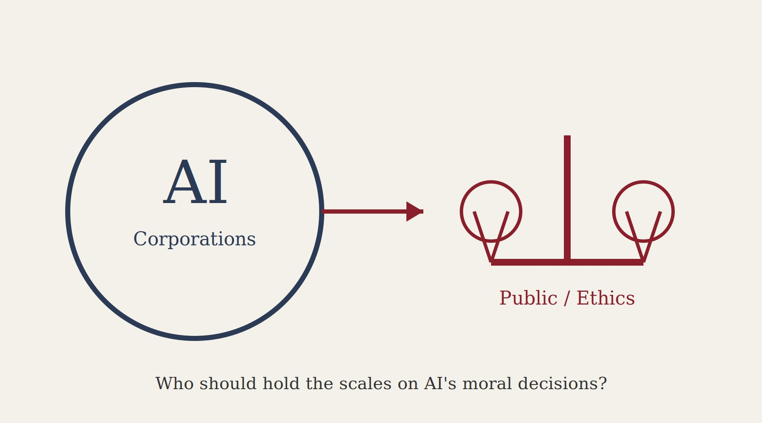
Figure: AI companies, not the public, currently make many of the moral choices embedded in AI systems.

Summary of the artefact

In this article, The Conversation speaks about how the technologies of artificial intelligence have come to make decisions that had been made earlier by humans – whether to mark a certain individual during their crossing the border, whether to approve a loan application, what individuals or groups weapons systems should be pointed at during a military conflict. They are moral decisions; however, today they are not being made by the government and even by citizens but by corporations.

Nonetheless, the major topic in the paper is Chris Olah, one of the co-founders of Anthropic, who delivered a speech beside Pope Leo XIV in the Vatican, expressing the fact that his occupation cannot be left to regulate itself because scientists such as he had been mistaken when they believed that it was up to them to ensure that the ethical use of AI be the concern of technical people. These were said by him in relation to the first encyclical of the Pope titled “Magnifica Humanitas.”

Furthermore, one more idea mentioned in this article is that of “ethics owner,” meaning that such individuals are employees of the technology companies, while being a part of the corporation that gets criticized, even though they should deal with the criticism. The authors of this article warn about the transformation of the corporate ethics of AI into “economy of virtue,” which would be the way to address the criticism by the corporation but would not change anything in terms of their behavior. As a rule, the authors note the importance of making sure that oversight goes beyond consultation and gives the possibility to common people to speak about what kind of morality should be embraced by AI.

Justification on why I chose the artefact

The main reason why I chose this particular article was because of the issues related to what has been discussed in class during the past week about ethics and ethical theory. Specifically, about how different ethical theories attempt to answer exactly the issue that this particular article raises. The questions asked in class were, "who decides on how much harm is acceptable?" and "who is going to make this decision?". Issues such as approval of mortgages, border crossing, and even targeting of enemies in war to be decided by an AI algorithm provided the context for our class discussion.

Before reading this particular paper, I would have perceived the topic of ethics in AI as one that was supposed to be solved by the organization itself using codes of conduct, responsible AI departments, etc. In other words, if the organization claimed to operate ethically in those spheres, that was all that I needed. But after reading this paper, my stance changed. The example in question of drug approval and safety of nuclear power plants gave me an understanding that sometimes, decisions must be made beyond the boundaries of the organization that benefits from it, even though the intentions of its employees are the best possible ones.

It relates to the way ICT affects the range of options I have to choose from, whether it’s my loan or the things on the Internet, in such a way that I’m not consciously aware of the ways and reasons behind that influence. This caused me to take the notion of accountability into consideration in a practical way: if the decision had been taken automatically concerning a particular individual’s finances or even safety, who would be accountable for this decision, and could this individual raise a question concerning it? The notion of having an independent regulatory body considering the public interests while making decisions, and not being made up entirely of technologists, seemed like a good compromise.

This topic brought me somewhat contradictory emotions about the issue in question. On the one hand, it sounds rather shocking that moral decision-making about the lives and work of people can be entrusted to the algorithms produced by certain companies, which business goals are rather obvious, and there is no way such trends can be regulated throughout the whole world, including Canada. On the other hand, it was very reassuring to see that the people working in the sphere of artificial intelligence are ready to admit the fact that the issue cannot be controlled by themselves, and it deserves discussion even in the Vatican.
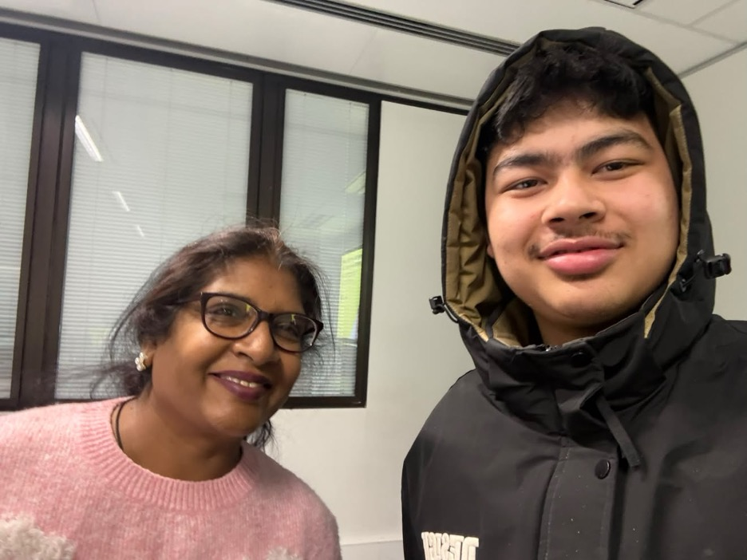

References

Vaast, E & Sieber, R 2026, 'Artificial intelligence raises profound moral questions — for all of humanity to answer', The Conversation, 16 June 2026, viewed 8 August 2026, https://theconversation.com/artificial-intelligence-raises-profound-moral-questions-for-all-ofhumanity-to-answer-284886

